THE CANDIDA YEAST-AUTISM CONNECTION

http://legacy.autism.com/triggers/candida_org.htm
By Stephen M. Edelson, Ph.D.
© 2007-2008 Autism Research Institute

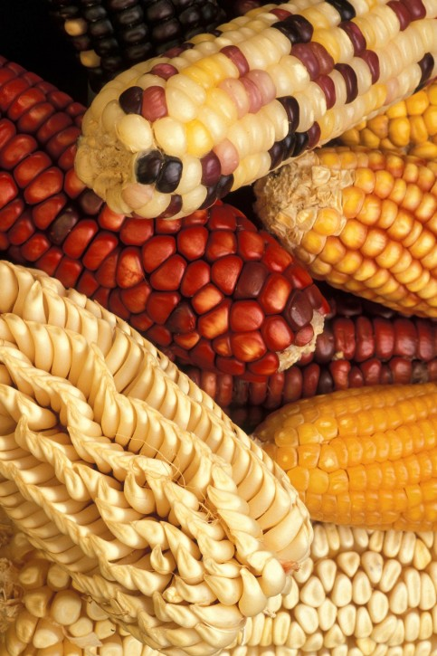
There is a great deal of evidence that a form of yeast, candida (rhymes with "Canada") albicans, may cause autism and may exacerbate many behavior and health problems in autistic individuals, especially those with late-onset autism.


Some of the behavior problems which have been linked to an overgrowth of candida albicans include: confusion, hyperactivity, short attention span, lethargy, irritability, and aggression. Health problems can include: headaches, stomachaches, constipation, gas pains, fatigue, and depression. These problems are often worse during damp and/or muggy days and in moldy places. Additionally, exposure to perfumes and insecticides can worsen the condition.

AUTISM & ENVIRONMENTAL TRIGGERS
http://parenting.amuchbetterway.com/autism-and-environmental-triggers CANDIDA: Unfortunately, factors such as antibiotic use and lack of breastfeeding can compromise the gut flora and allow organisms such as Candida Albicans to become the predominant species. This yeast can become parasitic when it is allowed to increase in numbers. It produces many toxic substances as a result of its metabolism, the main ones being ethanol (drinking alcohol) and acetaldehyde, an even more toxic chemical formed when ethanol is broken down in the human body.

.
For Updates of Information About Autism & Other Environmentally Connected Health Concerns,
Contact Liberty Goodwin, TIP Director,
at: liberty@toxicsinfo.org, 401-351-9193,
or visit the Toxics Information Project website at: www.toxicsinfo.org/healthconnections.htm, www.toxicsinfo.org/TIPS_kids.htm

FOOD & AUTISM CONNECTIONS


STUDY: AUTISM LINKED TO INDUSTRIAL FOOD, ENVIRONMENT
Published on Wednesday, April 11, 2012 by-
Common Dreams staff
www.commondreams.org/headline/2012/04/11-6

A new study by Clinical Epigenetics, a peer-reviewed journal that focuses largely on diseases, has found that the rise in autism in the United States could be linked to the industrial food system, specifically the prevalence of high-fructose corn syrup (HFCS) in the American diet. The study, published yesterday online, explores how mineral deficiencies could impact how the human body rids itself of common toxic chemicals like mercury and pesticides.

The report comes just after a different report, from the Centers for Disease Control and Prevention, documented a startling rise in autism in the United States. “To better address the explosion of autism, it’s critical we consider how unhealthy diets interfere with the body’s ability to eliminate toxic chemicals, and ultimately our risk for developing long-term health problems like autism.” said Dr. David Wallinga, a study co-author and physician at the Institute for Agriculture and Trade Policy.

T
THIS FLYER HAS BEEN PREPARED & PROVIDED BY:

TOXICS INFORMATION PROJECT (TIP)
Providence, RI Tel. 401-351-9193,
Liberty Goodwin, Director, E-Mail: TIP@toxicsinfo.org
WEBSITE: WWW.TOXICSINFO.ORG
(Lighting the way to Less Toxic Living)
CHECK OUT OUR NEW RI FOOD CONCERNS GROUP!

LINKS TO INFO ABOUT GMOS AND AUTISM



My Questions About Monsanto’s GMOs & Autism: Watching “The World According to Monsanto”, I was struck by the section of the film about Árpád Pusztai?s research that showed that rats fed GMO potatoes developed gut problems and an immune response.
www.wellsphere.com/autism-autism-spectrum-article/monsanto-gmos-my-questions-about-monsanto-8217-s-gmos-and-autism/11116

Are Genetically Engineered Foods Promoting Autism?

From Institute for Responsible Technology: The most comprehensive source of GMO health risk information

on the web. www.responsibletechnology.org/autism -

Lyme/Autism Group Blasts Genetically Modified Foods as Dangerous [Nov 17, 2011] Autism, food allergies, and GMOs. It is noteworthy that children with autism are often allergic to corn and soy. Both are genetically engineered.

www.huffingtonpost.com/jeffrey-smith/lymeautism-group-blasts-g_b_268580.html

L.I.A. Foundation: August 25, 2009 – The Lyme Induced Autism Foundation Prescribes 100% Non-GMO Diet Joins Moratorium on Genetically Modified Foods www.lymeinducedautism.com/gmopositionpaper.html

GMO’s: A Possible Link to Autism? Free Articles Directory. Consider the prevalence of food allergies among children with autism. The fact that the incidence of autism has exploded in conjunction with the introduction of GMOs.
www.articlesbase.com/.../gmos...link-to-autism-4119776.html
More results from articlesbase.com »

Blogging for Autism: “GMO’s, A Possible Link to Autism”. 2011 Recently, my friend Doreen Granpeesheh asked me about a documentary I watched titled The World According to Monsanto/Controlling Our Food, which gives extensive information on the dangers of GM foods

and genetically modified organisms (GMOs). .www.bloggingforautism.com/2011/01/26/gmos-a-possible

Genetically Modified Food & Autism: Is There a Connection? …(with the Bt (Bacillus thuringiensis) toxin found in patented, transgenic corn & cottonseed crops?)
http://gmofreelosangeles.wordpress.com/2011/05/30/its-time-to-be-honest-with-the-world-consuming-genetically-modified-food-may-cause-autism

8. Do GMO Foods Cause Autism? Read About the GMO Crops & Autism Connection. Independent scientists believe there is a GMO crops autism connection. Get the statistics, learn what genetically modified means.
http://healthy-family.org/do-gmo-foods-cause-autism

9. Autism & Genetically Modified Foods, It is common for a person with autism to have certain food allergies. http://throughtheeyesofautism.wordpress.com/2009/09/29/autism-and-genetically-modified-foods

GMO Lyme/Autism Group Blasts Genetically Modified Foods as Dangerous. 2009. Like the American Academy of Environmental Medicine, the LIA Foundation says there is enough evidence of harm in GM animal feeding studies to "urge doctors to prescribe non-GMO diets. www.dirtdoctor.com/organic/garden/view_org_research/id/195/

